**Microsoft Dynamics CRM Implementation at ABC Law Firm**

Professor David J. Gardner

Course Number: CIS9000

Team F

Tiffany Chang, Rieko (Kat) Kadoya, Mayumi Mori,

Pradnya Shah, Stephanie Su, Neelam Swami

**INDEX**

1. Executive Summary
2. Company Background
3. Information on Microsoft Dynamics CRM
4. Implementation
   1. Decision process
   2. Initial Technology deployment
   3. “Concep” - Microsoft Dynamic CRM System Integration
5. Analysis
6. Recommendations
7. Conclusion
8. Exhibits
9. References

**Executive Summary**

IBIS World’s report on US law firms projects that the industry will reach $325.8 billion by 2020. Although the report anticipates continued growth in the number of businesses by 2025, the industry is at a mature life cycle stage. Hence, it is crucial for law firms to maintain its competitiveness through aggressive strategies in business developments.

Similar to most businesses, law firms’ attorneys look to experts in the marketing department to identify and grow their clientele. While the experts’ experiences and understanding of the business is crucial, a well-maintained customer relations management (CRM) system could significantly decrease the time needed in communication and increase the possibility of success rate.

This paper analyzes the ABC firm’s current usage of the Microsoft Dynamic CRM 2013, deployed in 2015. While the system has been functioning for years, we collected multiple complaints during our interviews with the firm employees, including marketing team members, IT Director, and legal assistants. After dissecting the decision making process and system implementation process, the root causes of the existing problems of the CRM system began to emerge. Following that, our team provided actionable and feasible recommendations that should be immediately taken into action with considerations to the current market uncertainties caused by the coronavirus pandemic.

**Company Background**

Established in 1991, ABC firm is a Dallas-based law firm with more than 165 trial lawyers across seven locations in the US with Dallas, New York and Los Angeles being the three largest offices. ABC firm has established a reputation as being one of America’s leading trial firms. It specializes in high-risk litigation, intellectual property, insurance recovery, bankruptcy, and white-collar defense matters for both corporations and individuals. Moreover, the firm represents and provides legal services to companies across numerous industries, including technology, telecommunications, industrial manufacturing and financial services. As of May 1, 2020, the firm had over 290 full-time employees.

With increasingly fierce competition in the legal industry, the management, capturing and sharing of past interactions with clients, prospects and referral sources become a critical necessity for a law firm. One of ABC’s critical competitive advantages is its continuous investments in technology and understanding that an advanced infrastructure lends higher value to the services provided. The investments also increase efficiency, improves performance, and ultimately helps it win cases. An efficient CRM system, specifically tailored to law firms, not only assists in addressing these concerns but also helps to expand its client base in the legal industry.

**Information on Microsoft Dynamics CRM**

Microsoft Dynamics CRM is a server-client application and part of the Microsoft Dynamics family of business applications. It is primarily a Customer Relationship Management software package designed to improve business outcomes across three fundamental areas: sales, marketing and customer service. Microsoft Dynamics CRM aims to offer a simple, easy to learn experience for those familiar with office products keeping training requirements to a minimum. It also enables various teams in the organization to collaborate and cooperate with each other, with sharing capabilities to real-time account data. With the robust analytics of the CRM system, one can easily target and categorize customers, understand their needs, and deal with them at the right time with the most appropriate response.The information in the CRM, enhanced with relationship insight and competitive intelligence, is conveniently accessible and editable by users on a mobile or tablet device. The system can be deployed in the cloud, on-premise and integrated to existing systems to improve information sharing.

ABC firm utilized Microsoft Dynamics CRM system to manage customer relationships. The system especially aimed to assist the marketing team in tracking the strength of relationship with each client and connecting attorneys to potential leads. ABC firm’s license for Microsoft Dynamic CRM could set up 200 accounts. The monthly subscription fee for the Thomson Reuters Elite systems, ABC’s provider, adds up to roughly $4,000 each month.

The Microsoft Dynamic CRM in ABC firm currently has four predefined access groups for the end-users: Administrators, Lawyers, Marketing Assistants and Secretaries. The grouping helps set constraints on access to confidential information preventing any potential misuse at the undesired level.

**System Implementation**

*Decision Making Process*

The ABC firm, with a family-like culture, operates on informal structure as a whole, following a functional perspective where each department develops its own governance. According to the interview with the IT Director, when the marketing department sought a CRM system, the Microsoft Dynamics CRM was available as one of the packaged systems offered by Thomson Reuters Elite. The marketing department valued it because they can link it to other packaged systems easily and take advantage of ERP such as obtaining good service support. Normally, within the IT department, each project is assigned a project manager and the formal management plan is executed extensively. However, the IT department was not involved in the decision making process of selecting a CRM system for the firm. The decision to implement a CRM system was made by the Director of Marketing, then approved by ABC firm’s Executive Director in 2015. The board of directors is rarely involved in the information system related matters. Due to poor documentation of the decision making process and the Director of Marketing who made the decision had already left the position, the Director of IT was unable to provide any in-depth rationale on selecting the Microsoft Dynamic CRM over other CRM systems.

*Implementation*

As the firm already operated on Thomson Reuters’ financial management system, the IT team did not encounter major obstacles when implementing the Microsoft Dynamics CRM. For instance, the Microsoft Dynamic CRM is a VMware based virtualized server platform and uses the same Microsoft backend products that ABC firm’s system is built on, including Windows Server, SQL, IIS. A total of three IT staff were assigned to this project. One built the VMwares needed to run the CRM system per Thomson Reuter’s specifications, a second worked with Thomson Reuters’ engineers and technicians on the imports to CRM of ABC firm’s existing contacts and other data, and the third performed training and created “Quick Reference Card” for CRM (Exhibit 1). The implementation cost totaled at roughly $24,000.

Following the deployment of the system, the IT department staff provided general training and “Lunch and Learn” programs to educate all client-facing staff, including attorneys and their legal assistants, and marketing department on how to use the Microsoft Dynamics CRM system. Today, all new hires into the same role receive the training on their first day orientation. In addition, the Help Desk, an email inbox operates 24/7 and is available to handle any system issues. While the IT department has the capacity to provide data and tracking on the system usage, there is no demand or request to track such usage.

*Adopting another email campaign system, ConsepSend*

The main users of the CRM system, the marketing staff complained about the poor connectivity with “Monitor Suite,” a Thomson Reuters Elite legal information system. New hires in the marketing department didn’t know how to utilize Microsoft Dynamics CRM effectively for their new marketing campaigns after the original members left the company. Moreover, they couldn’t find enough client information updated by Attorneys or their assistants on that CRM system, instead, they received the list from the attorneys that had only clients’ email addresses via email.

In 2017 the online marketing tool ConcepSend was developed and integrated with Microsoft Dynamics CRM. This platform enhanced the existing features and allowed users to create, manage interactive email campaigns, surveys, and event registration, and display easy-to-view dashboards that showcased the engagement with clients. To address the above concerns, ABC firm’s marketing department switched to ConcepSend from Microsoft Dynamic CRM, however, ABC firm’s IT department was completely unaware of such plug-in and were not involved in the system upgrade. Only one person in the marketing department received training from ConcepSend support team. Afterwards, marketing staff compiled a manuscript to document how to send email campaigns through ConcepSend (Exhibit 2) as future reference for new hires into the marketing role. With access to both Microsoft Dynamic CRM and ConcepSend, the usage on the former system decreased. However, marketing staff still keep their access to Microsoft Dynamic CRM, hoping the end users will continue to update clients information.

**System Analysis**

To understand the CRM system landscape, an analysis of the responses gathered using both telephonic interviews and open-ended questionnaires surveys was made. We collected information from respondents ranging from managers and end users across the Information Technology, Marketing and Business Development department. As noted earlier, the CRM system was implemented with an aim of allowing the marketing department to administer email campaigns and analyze real time insights to increase the client base of the law firm. It further allowed the ability to assess-relative strength of each relationship so that the organization can put the right lawyers in front of a particular client. The system, although theoretically adequate for the organization, suffers from pragmatic issues across the entire system lifecycle listed below.

*Lack of Shared Vision for the System*

Bringing together responses from a broad spectrum of responders, we found that the firm lacked a well-planned strategy required for requirement gathering, selection, implementation and subsequent governance of the CRM system. As one of the responders noted that the CRM selection process was undertaken by a single individual and there didn’t exist any interdepartmental coordination to understand the organizational requirements. A lack of benchmarking against the existing systems (FirmSeek and ConcepSend) resulted in Microsoft Dynamic CRM having an overlap of scope and abilities. Further, there is a lack of engagement of the required stakeholders during the system implementation life cycle resulting in convoluted decision making. The system thereby fell short of its vision to be a singular driver of the firm’s client engagement initiatives.

*Lack of Governance*

Based on marketing and business administration department responders, the CRM system suffers from a debilitating lack of effort to record and update the information in the system. Although secretaries and paralegals at the law firm have been tasked by the lawyers to update customer information into the CRM system, the data is not being imported promptly by them. This is because secretaries and paralegals lack the understanding of the marketing team’s objectives and the kind of the information the marketing teams required. There is also no emphasis from the law firm to ensure timely data updates. As a result, the organization does not have an effective governance policy in place to monitor and persuade secretaries and assistants to do the same. *Adoption of CRM system*

During our research, some respondents complained there is a low adoption rate of CRM systems within the entire firm. An investigation of the responses revealed a dichotomy. A majority of successful senior attorneys are not utilizing the CRM system owing to system complexity (non-intuitive system user interface) and lack of awareness of system functionality. Meanwhile, the junior attorneys, however, being more tech savvy were noted to leverage the systems capabilities to increase their success rate. The law firm did not have any system or behavioural training in place to deal with low adoption rate issues.

There are also privacy concerns. First, the attorneys feel that the existing privacy and constraint features on the CRM system are not adequate in comparison to Outlook for storing client data. We found that importing client data in the CRM system is challenging because attorneys rely mostly on outlook data for direct contact with their clients because of privacy reasons. Second, attorneys have to share their client information in excel sheets for email-marketing purposes. This practice of excel data sharing increases attorneys' concerns for intra organization competition and data privacy, because excel data is not secured and could be used by other lawyers in the firm.

Furthermore, Attorneys and marketing teams, who in theory should benefit from each other’s association are rather suffering owing to lack of sufficient participation. The marketing team uses ConcepSend to administer email campaigns, the results however are not shared with the attorneys as they are not using the ConcepSend. There is a lack of strategic alignment between attorneys and marketing teams.

Thus, the observations underline major issues pertaining to higher effort requirement, lower performance returns and lack of facilitating conditions (training, organizational support, data privacy) all noted in technology adoption theories such as UTAUT (Unified theory of acceptance and use of technology) to be the key drivers of usage. An emphasis on remediating the issues noted above has been laid in the following section to allow for optimal usage and adoption of the CRM system.

**Recommendations**

Considering economic efficiencies caused by the coronavirus pandemic, the company faces difficulties to acquire or upgrade the system in the near future. We would like to propose the following recommendations based on our analysis:

*Build business strategy, then share it with teams and enforce it*

First of all, ABC firm directors need to establish a mechanism on developing business strategies for information systems. The process should include the steps of identifying, understanding, and analyzing the activities the firm performs so these IS resources can enhance the firm activities. As the four components of the information system, including technology, process, people, and structure, are interdependent, the systemic effect needs to be considered when designing the business strategy. Following that, the objectives of the information system need to be shared with all employees and clearly identify the roles in each department. Based on the business strategy, the IT department is responsible to develop these rules, structure the flows and processes for system implementation and management.

*Emphasize effective governance*

ABC firm should keep an up to date archive of CRM system data by mandating regular client data entry and related documentation. Updating information in the CRM system on time can be helpful for identifying clients’ demand across multiple touchpoints within the firm. By putting apt governance rules in place, the company can lay an enhanced emphasis on organizational knowledge management and dissemination. Further, the organization should designate a single point of contact from the marketing department for undertaking customer engagement efforts to prevent any duplication. Availability of current data in the system will help ABC firms to maximize potential business value and empower linkages with customers.

*Provide comprehensive training*

Besides the existing “Lunch and Learn” programs we recommend the firm to offer behavioral training to overcome concerns such as user resistance due to age group and emotional barriers. In addition, the IT department can upload more fundamental instructions and create Q&A functions about CRM features and capabilities on the company-wide intranet to increase employee knowledge of the CRM system based on the cooperation with end users. The Q&A functions can create an opportunity for end users to ask questions about functions they do not understand or to discuss their concerns about an aspect of the CRM. These opportunities would thus reinforce perceptions for enhancing performance and reducing the effort required.

*Monitor and increase CRM system adoption*

The IT department should coordinate the meeting among all stakeholders to understand their needs in expanding businesses. As part of the strategy, the team needs to come up with agreed KPIs to measure its success. The IT department also needs to analyze the end user activity and data, to divest the systems that are losing causes. Also, the marketing staff could share past successes to convince the attorneys on adopting the system. For instance, developing a case study on how tech proficient lawyers leveraged the CRM system to retain new clients. This could encourage and boost CRM system acceptance among senior attorneys.

*Introduce a customizable data encryption function*

The IT department in ABC firm should enhance system capability to perform client information encryption to allay concerns of intra organization competition. Data encryption process is going to be a first order change or automate change in the CRM system which is easy to carry out and requires for privacy improvements in the system. The IT department should provide customizable data encryption features in the CRM system to eliminate data privacy concerns of attorneys and other end users. Encryption can ensure that if wrong individuals gain access to the data, they will be unable to make out its meaning.

**Conclusion**

The CRM initiative is a strategy enabled by the technology. Overall, ABC firm has a solid technology team with an experienced IT Director supporting the systems functionality and maintenance. However, an unclear strategy and lack of corporate governance discussed in our analysis resulted in the inefficient usage of the Microsoft Dynamic system. To improve the adoption, all stakeholders need to be included in the strategy development to achieve optimization of the already invested system. Therefore, applying the above mentioned recommendations, the ABC law firm can increase client data availability that will improve client acquisition and retainment.

**Exhibits 1 - The Company’s Quick Reference Card**

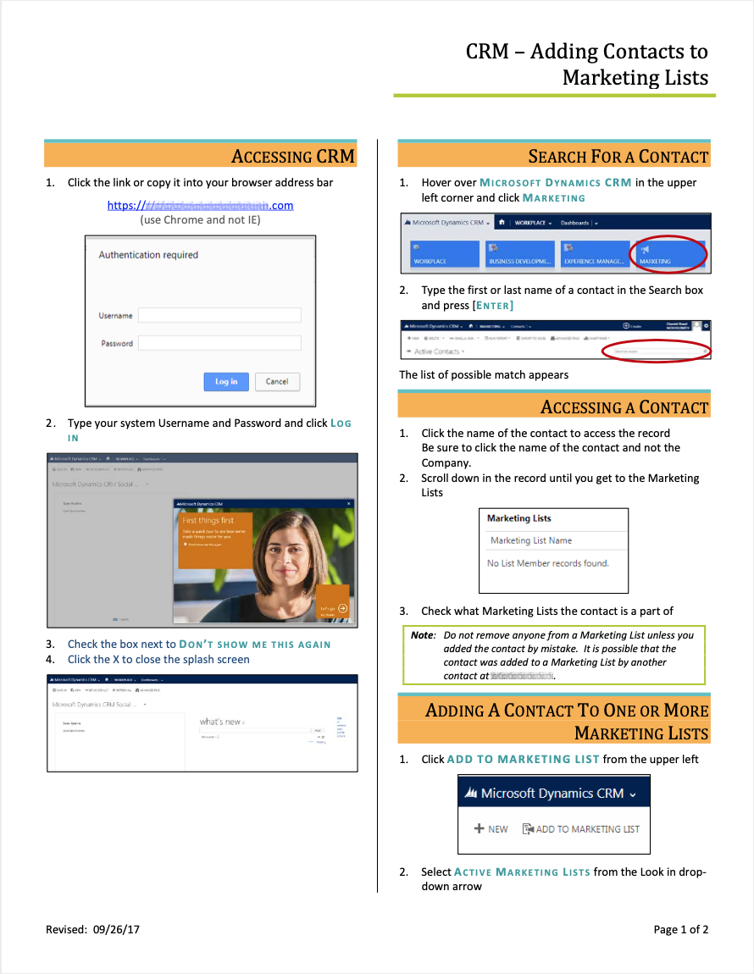

**Exhibit 2 - A page of marketing staff developed manuscript for sending email campaign through Microsoft Dynamic CRM**

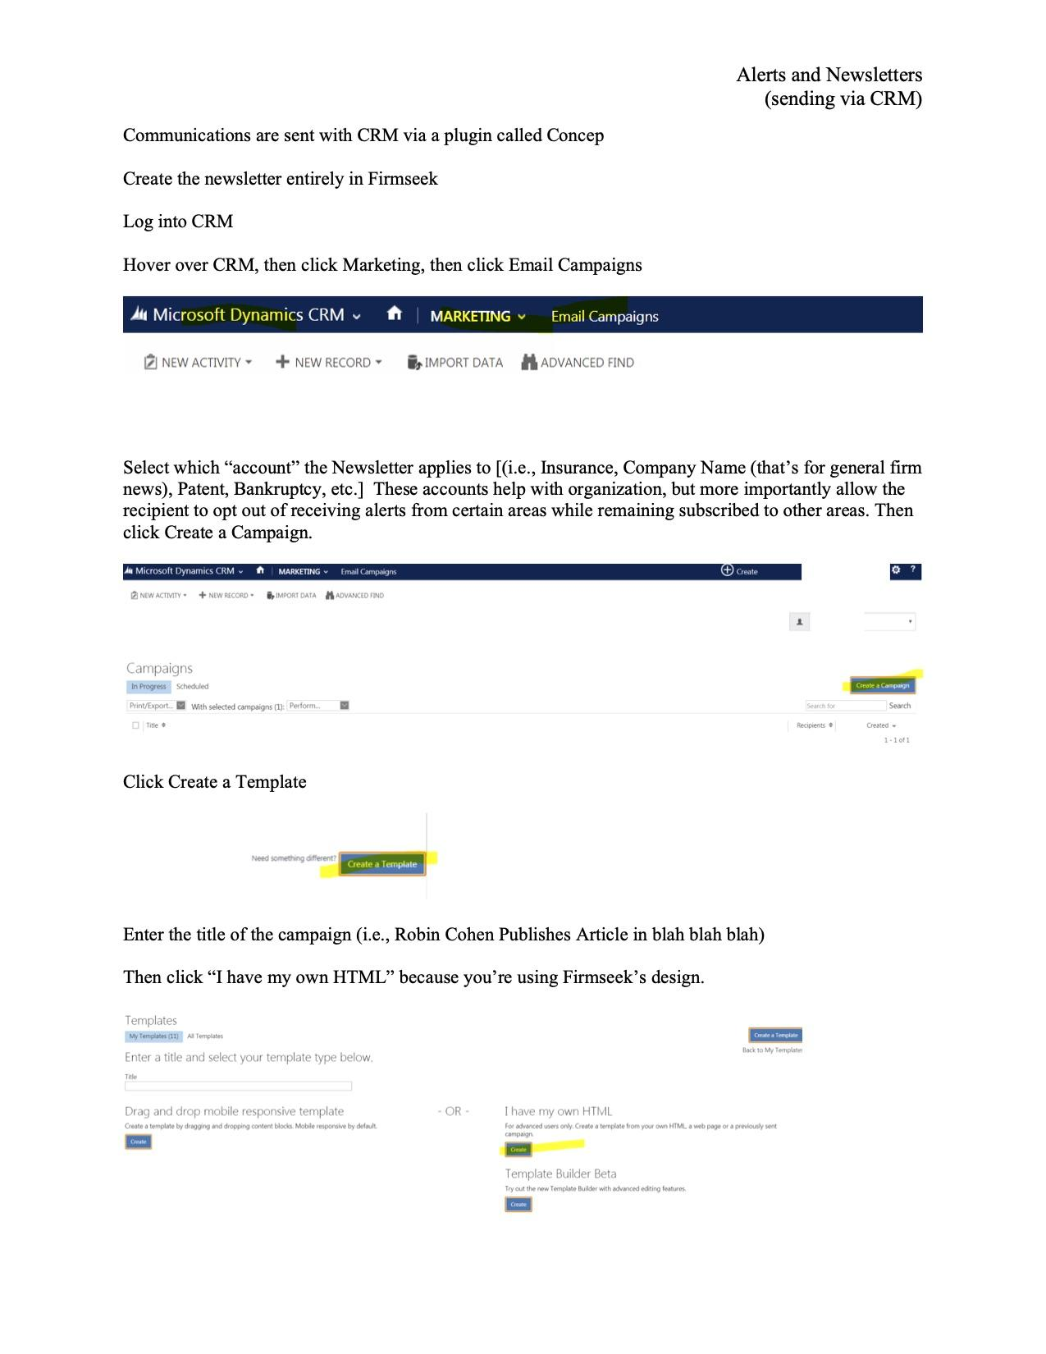

**References**

1. "14 Microsoft Dynamics CRM Advantages and Disadvantages ...." <https://brandongaille.com/14-microsoft-dynamics-crm-advantages-and-disadvantages/>. Accessed 18 May. 2020.
2. "List of Companies Using Microsoft Dynamics CRM ... - InfoClutch." <https://www.infoclutch.com/installed-base/crm/microsoft-dynamics-crm/>. Accessed 18 May. 2020.
3. "Unified theory of acceptance and use of technology - Wikipedia." <https://en.wikipedia.org/wiki/Unified_theory_of_acceptance_and_use_of_technology>. Accessed 18 May. 2020.